Helpdesk Module – Functional Requirements Specification

1. General Overview
The Helpdesk module must be built within the existing ERP system and appear under the Helpdesk tab (not as a separate application).
The system must support:
- Manual ticket logging
- Email-based ticket logging
- Technician assignment (manual & randomized)
- Requester self-service access
- Notifications
- Scheduling
- Reporting
- Role-based permissions
Examples and screenshots will be supplied separately where referenced.

2. Home Page (Helpdesk Dashboard)

Visibility
- Admin users must see all open calls on the home page.
- Non-admin users should only see calls assigned to them.
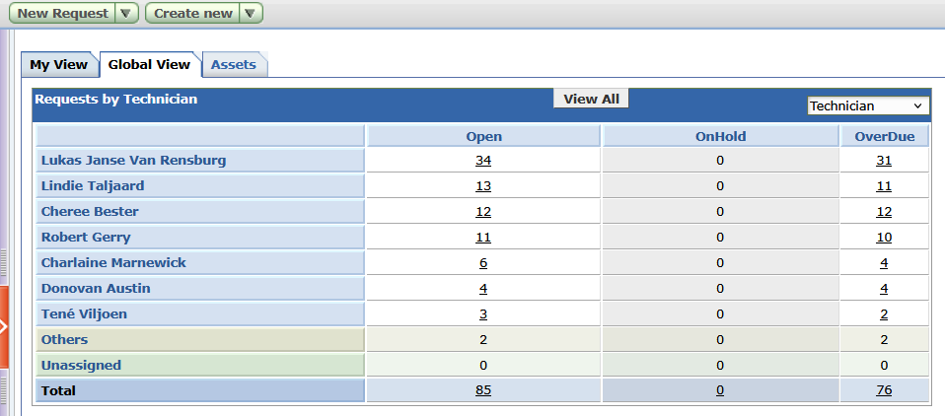

Layout
- Layout example will be provided.
- Each call should display key information (subject, requester, technician, status, due date, etc.).

Actions
- Button to Log a New Request must be available.

3. New Request (Manual Ticket Logging)

Required Fields
- Client
  - Dropdown
  - Must pull from existing Client Database
- Requester Name
  - Dropdown
  - Must pull from Requesters (Admin Section)
- Technician
  - Dropdown
  - Must pull from User Logins (Reporting & Admin)
- Due By Date (date selector)
- Subject
- Description
- File/Image Upload
- Add Request button

4. Technician View (When a Technician is Selected)
When opening a call assigned to a technician, the view must display:
- Subject
- Requester Name
- Due By Date (default: next working day)
- Created Date
- Helpdesk ID Number
- Notes (text field)
(Visual example will be provided.)

5. Admin Section (Under Helpdesk Tab)

5.1 Mail Server Settings

Incoming Mail
- POP mail configuration
- Must function the same as existing Backup Monitoring POP Mail
- Used to automatically log tickets from emails

Outgoing Mail
- SMTP server configuration
- Used for notifications
- Example configuration will be provided
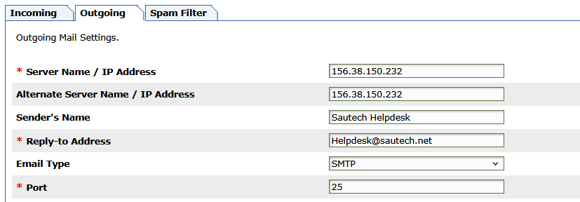

5.2 Notification Rules
- System must support configurable notification rules
- Rule layout and logic will be provided via screenshot

Email Templates
- Templates must be:
  - Customizable
  - HTML-based
  - Able to include images
- Example templates will be provided
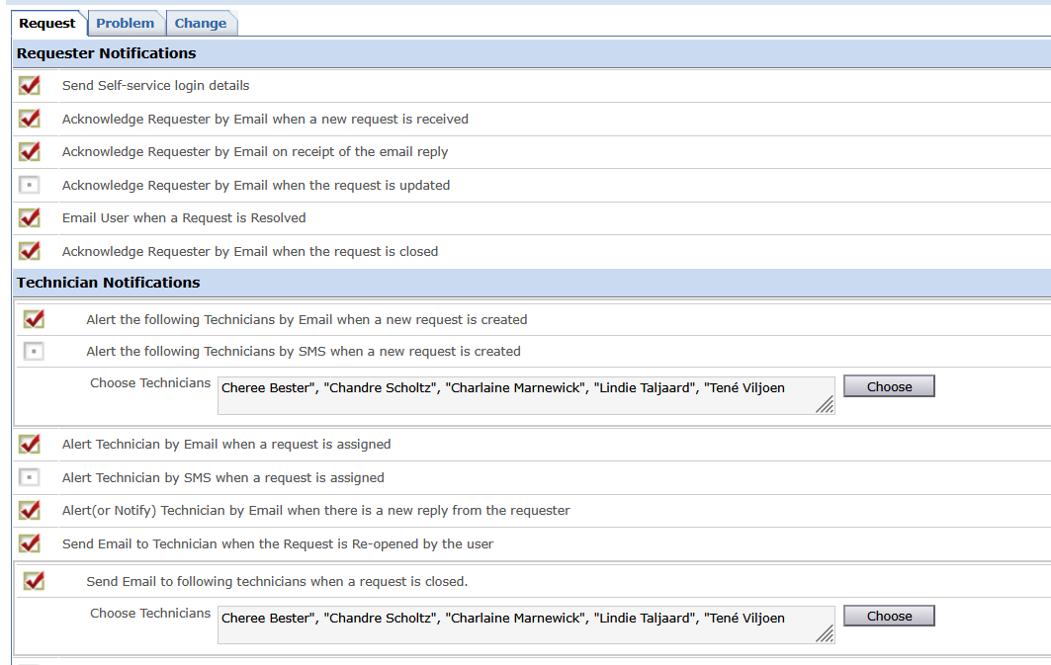

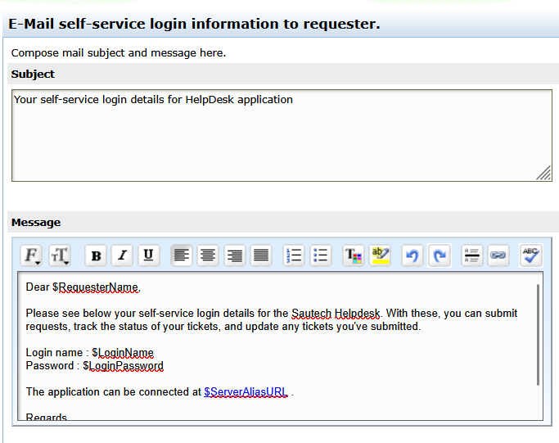

5.3 Requester Notifications
- When a new requester logs a call for the first time, they must receive an email containing:
  - Self-service login link
  - Login name (email address)
  - System-generated password
- Requesters must only be able to:
  - Log in
  - View their own logged calls

6. Scheduled Calls

Scheduled Calls List View
When opening the Scheduled Calls tab, display:
- Subject
- Requester Name
- Created Date
- Edit option
- Log Again option
- Delete option

Add New Scheduled Call

Required Fields
- Client (from Client Database)
- Requester Name (technician selectable)
- Technician
- Subject
- Description
- File/Image Upload

Task Schedule
Must support:
- Daily
- Weekly
- Monthly
- Periodic
- One-time schedule
- Add Request button
(Task scheduling example will be provided.)
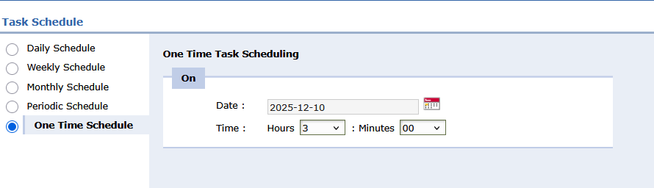

7. Requesters Management

Requesters List View
Display:
- Name
- Email
- Work Number
- Mobile Number
Must be able to:
- Add
- Edit
- Delete requesters

This should be in the dropdown when adding/creating a call.

Add New Requester

Fields
- Client (from Client Database)
- Requester Name
- Email Address
- Work Number
- Mobile Number

Behavior
- On save:
  - Automatically create self-service login
  - Login name = Email Address
  - Password = Randomly generated
- When editing a requester:
  - Must have option to reset password

8. Reports Tab

8.1 Billing Report
- Must allow selection of a date range
- Monthly reporting required

Report Fields
- Client
- Helpdesk ID Number
- Time Spent
- Created Date
- Closed Date
- Technician
- Subject
- Worklog Description
- Service
- Unit Price

8.2 Other Reports
- Open Call Report
  - Export all open calls OR filter by technician
  - Date range selectable
- Closed Call Report
  - Export all closed calls OR filter by technician
  - Date range selectable
- On Hold Call Report
  - Export all on-hold calls
  - Must include on-hold description
- Overdue Call Report
  - Export all overdue calls

9. Role Permissions (Reporting & Admin Section)
This does not fall under the Helpdesk tab.

Manage Role Permissions
Must be configurable per user, including:
- Create calls
- Edit calls
- Delete calls
- Merge calls
- Close calls
- Randomize assignment
- Time sheet access
- Manual time entry
- Assign & reassign calls

Randomized Assignment Logic
- If a user has Randomize permission:
  - Calls logged manually or via email must be automatically assigned
  - Assignment must rotate between selected users
  - User with least open calls should be prioritized

10. Technician Call Actions
When a technician opens a call, the following must be available:

Call Status
- Dropdown:
  - Close
  - On Hold

Description
- Text field
- This description is sent to the client

Worklog
- Checkbox: Add to Worklog
- Worklog entries:
  - Must not be visible to the client

Time Sheet
- Start Time
- End Time
- Users with timesheet permission:
  - Must not be allowed to close calls without time entered
  - Time should not be altered, must use start and end time button (Play & Pause buttons)

Service & Pricing
- Service Category
  - Pulled from Admin Services – Manage Service Categories
- Unit Price
  - Pulled from Admin Services – Unit Price

Worklog Description
- Internal text field (not client-facing)

On Hold Rules
- When setting a call to On Hold:
  - Description/Note is mandatory
  - Client must not receive an email notification

11. Overdue Call Logic
- Calls logged manually or via email:
  - Must only be marked Overdue after 48 working hours
  - Working hours are Monday to Friday only
  - Weekends must be excluded from calculation

